SCHOOL OF COMPUTER SCIENCE AND ARTIFICIAL INTELLIGENCE |  |  |  |  | DEPARTMENT OF COMPUTER SCIENCE ENGINEERING
Program Name: B. Tech |  |  |  | Assignment Type: Lab |  |  | Academic Year:2025-2026
Course Coordinator Name |  |  |  | Dr. Rishabh Mittal
Instructor(s) Name |  |  |  | Mr. S Naresh Kumar  Ms. B. Swathi  Dr. Sasanko Shekhar Gantayat  Mr. Md Sallauddin  Dr. Mathivanan  Mr. Y Srikanth  Ms. N Shilpa  Dr. Rishabh Mittal (Coordinator)  Dr. R. Prashant Kumar  Mr. Ankushavali MD  Mr. B Viswanath  Ms. Sujitha Reddy  Ms. A. Anitha  Ms. M.Madhuri  Ms. Katherashala Swetha  Ms. Velpula sumalatha  Mr. Bingi Raju
CourseCode |  |  | 23CS002PC304 | Course Title |  | AI Assisted Coding
Year/Sem |  |  | III/II | Regulation |  | R23
Date and Day  of Assignment |  |  | Week11 – Wednesday | Time(s) |  | 23CSBTB01 To 23CSBTB52
Duration |  |  | 2 Hours | Applicable to  Batches |  | All batches
Assignment Number:22.3(Present assignment number)/24(Total number of assignments)
 | Q.No. | Question |  |  |  |  |  | Expected Time  to complete
 | 1 | Lab 22 – Advanced Ethical Considerations: Addressing Complex Scenarios and Limitations  Lab Objectives:  - Understand ethical concerns in AI-assisted coding.  - Explore complex real-world scenarios where AI decisions have consequences.  - Learn to identify limitations and biases in AI-generated solutions.  - Encourage critical thinking and human responsibility in AI collaboration. |  |  |  |  |  | Week11 - Wednesday
Task 1 – Bias Detection in AI Suggestions (Alternative Example)
Example Scenario:
Ask AI to generate a resume shortlisting algorithm multiple times.
- Change prompt wording (e.g., “select best candidate” vs “ensure diversity”).
- Compare outputs and logic.
Discussion Points:
- Does the AI favor certain qualifications, backgrounds, or experiences?
- How could biased shortlisting algorithms affect equal employment opportunities?
PROMPT: Write a JavaScript program to shortlist candidates based on marks, experience, and university ranking. Show the output with selected candidates.
EXPLAINATION: AI shortlisting may favor candidates based on marks, college, or experience, which can create bias.
Different prompts can change how fair or inclusive the selection process is.
This shows that AI needs careful guidance to ensure equal opportunities.

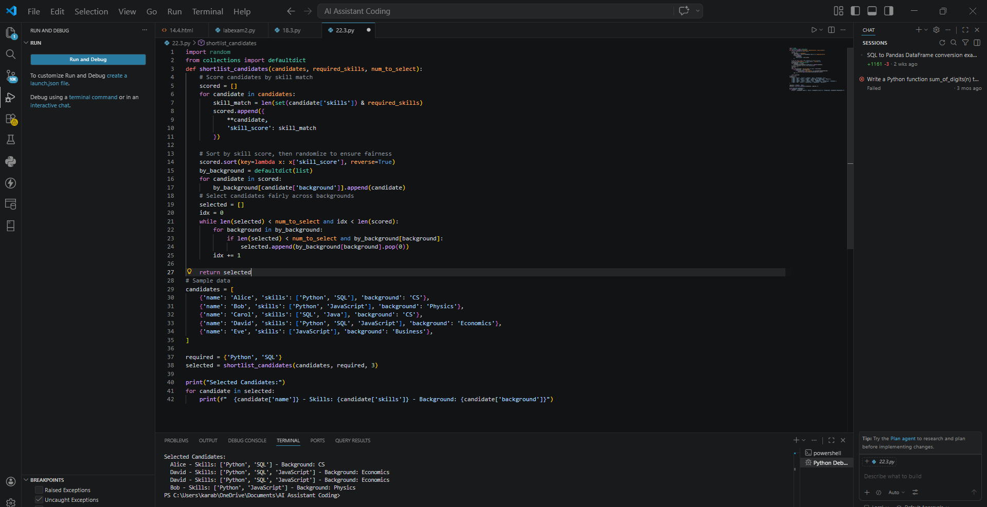

Task 2 – Privacy and Sensitive Data Handling (Alternative Example)
Example Scenario:
Ask AI to write code for processing student academic records (roll number, marks, email).
Discussion Points:
- How should student identity data be masked or encrypted?
- What privacy laws (e.g., FERPA, GDPR-like principles) are relevant?
- What ethical responsibility does the programmer have when using AI-generated code?
PROMPT: Write a JavaScript program to store and display student records including roll number, marks, and email. Also show the output.
EXPLAINATION: Student data like email and marks are sensitive and must be protected.
AI-generated code may expose such data if not handled properly.
Developers should use masking and encryption to ensure privacy.

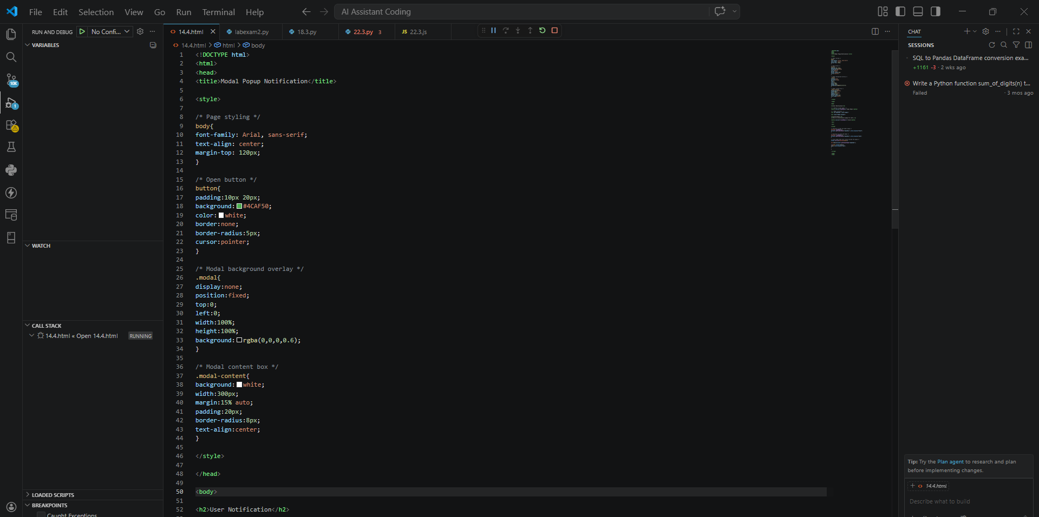
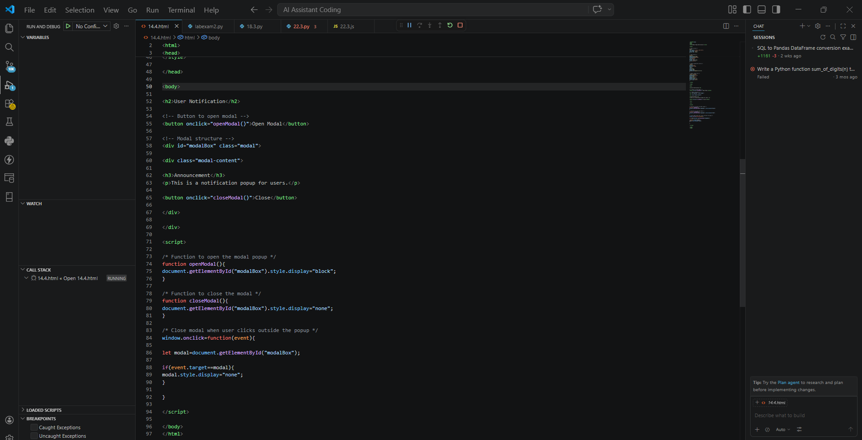
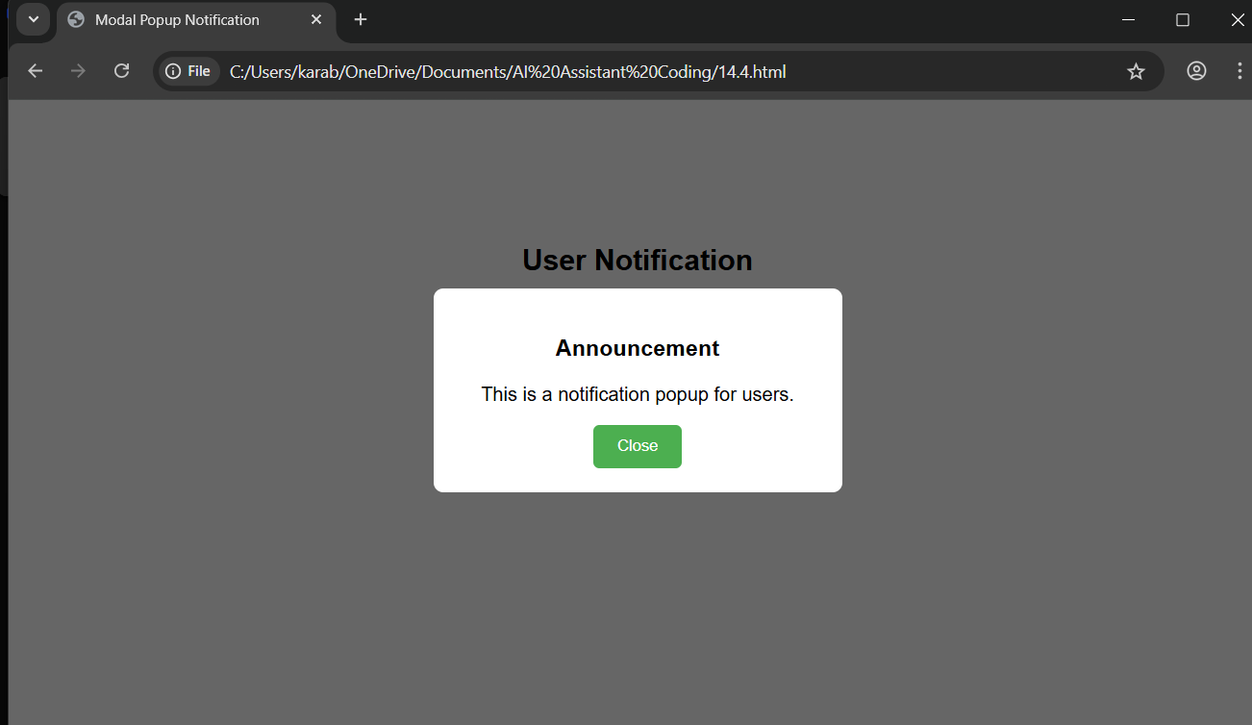

Task 3 – AI-Generated Security Risks (Alternative Example)
Example Scenario:
Use AI to generate a payment processing script for an online shopping system.
Student Tasks:
- Identify risks such as:
  - Plain-text card data storage
  - Missing input validation
- Propose ethical coding standards to prevent financial fraud and misuse.
PROMPT: Write a JavaScript program to process online payment using card number and print the payment details
EXPLAINATION: AI-generated payment code may store card details in plain text, which is unsafe.
Lack of input validation can lead to security vulnerabilities.
Secure coding practices are necessary to prevent fraud and misuse.

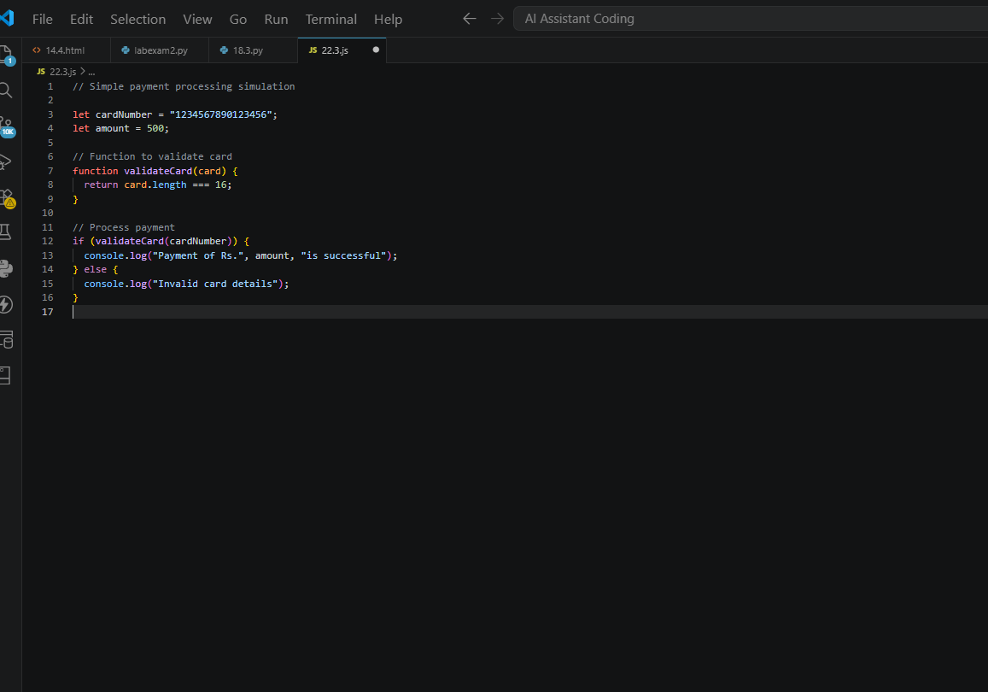
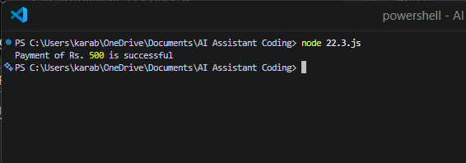

Task 4 – Accountability in Human–AI Collaboration (Alternative Example)
Scenario:
AI generates code for an autonomous traffic signal control system.
Discussion Questions:
- If a software error causes accidents, who is accountable?
- Should responsibility lie with:
  - AI tool developers
  - Software engineers
  - Government authorities deploying the system?
Students submit a short reflection on accountability.
PROMPT: Write a JavaScript program to simulate an automatic traffic signal system using timers and display the signal changes as output
EXPLAINATION: AI systems can make mistakes, but responsibility lies with humans.
Developers and organizations must test and verify AI-generated code.
Accountability should be shared among developers, deployers, and authorities.

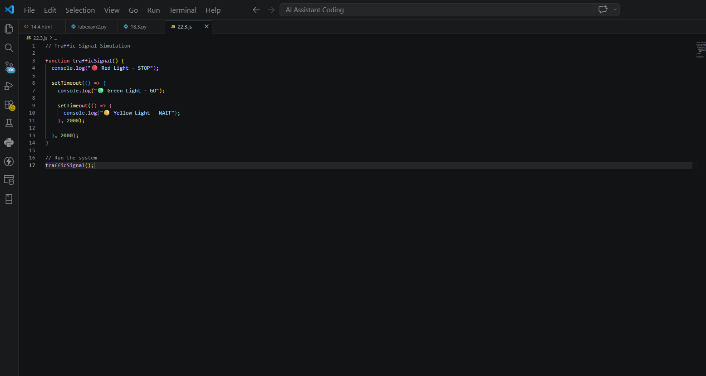
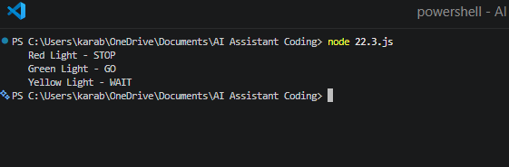

Task 5 – Limitations of AI in Critical Systems (Alternative Example)
Example Scenario:
Ask AI to generate code for an aircraft maintenance fault detection system.
Discussion Points:
- Can AI-generated code be trusted without expert validation?
- What human oversight is essential in aviation software?
- How should safety-critical code be reviewed and certified?
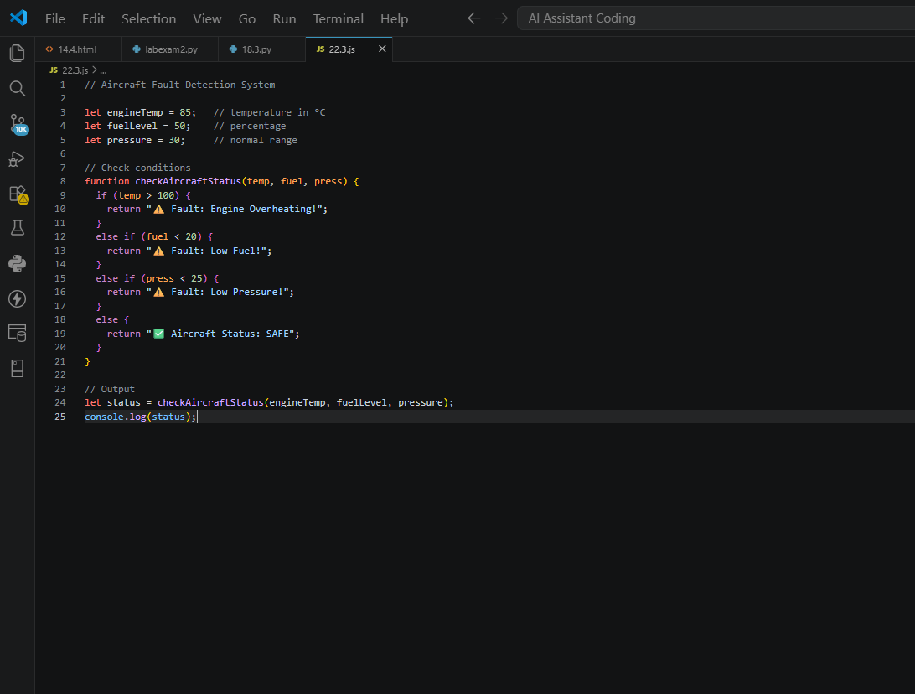
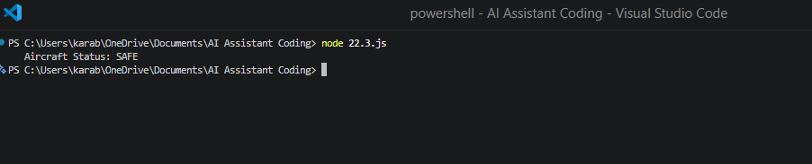
PROMPT: Write a JavaScript program to detect faults in an aircraft system using input values and display whether it is safe or not.
EXPLAINATION: AI-generated code may not be reliable for safety-critical systems like aircraft.
It can produce errors without understanding real-world risks.
Human experts must review, test, and certify such systems before use.

Task 6 – Ethical Use of AI-Generated Code (Alternative Example)
Example Scenario:
Students analyze cases where AI-generated code is used in academic assignments or startups.
Discussion Points:
- Risks of submitting AI code without understanding it
- Copyright and license violations
Best practices:
  - Proper citation
  - Manual verification
  - Ethical reuse of AI outputs
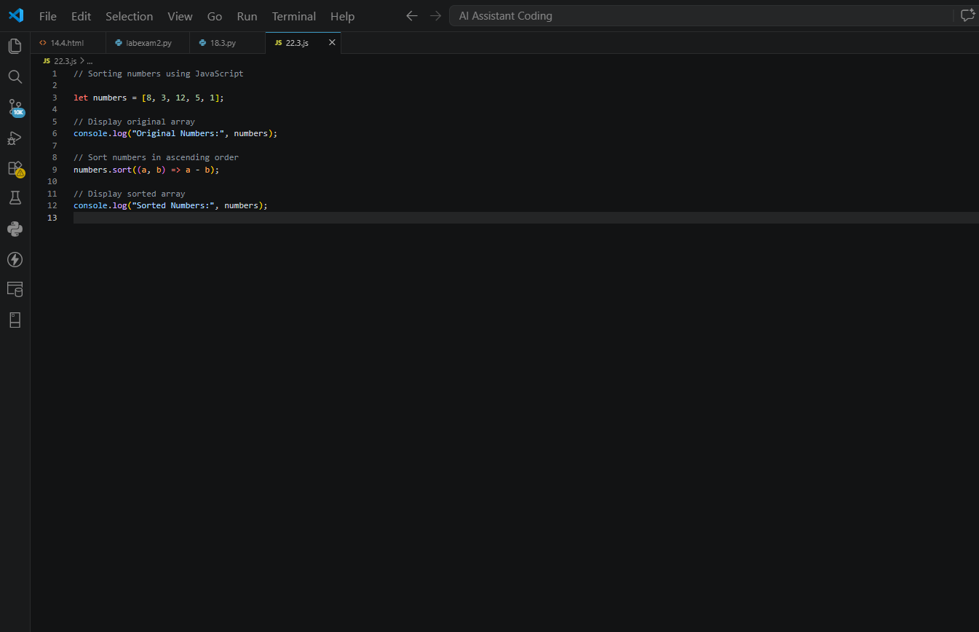
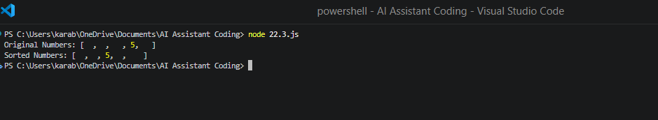
PROMPT: Write a JavaScript program to solve a basic problem (like sorting numbers) and display the output
EXPLAINATION: AI-generated code should not be copied blindly without understanding it.
Using such code without learning can affect skills and may lead to plagiarism.

Note: Report should be submitted as a word document for all tasks in a single document with prompts, comments & code explanation, and output and if required, screenshots.

